**Customer Support**

The IndoMarche system has built-in modules to handle customer supports. It has a complete inbox module where you can receive the messages, and also draft or send the messages. To handle the disputed orders, you are also provided with the dispute and refund modules.

All the modules that are available in this section are:

* Messages
* Dispute
* Refunds

**Messages**

This module is specially designed to communicate with the customers. With this module, you can personally chat with the customer through the messages.

SUPPORT DESK >> MESSAGES

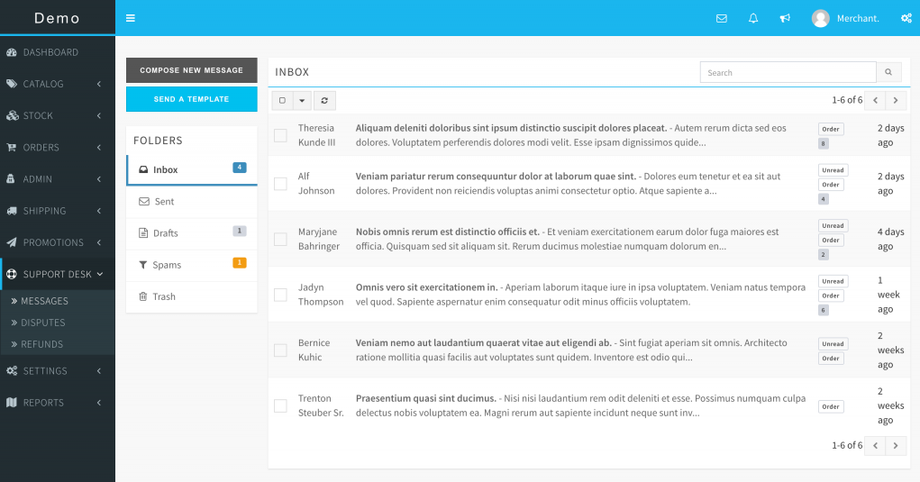

*Send an Email Template*

To send an email template that is already saved with you, select the SEND A TEMPLATE option when you want to compose and send it.

To create the Email templates with IndoMarche, go to SETTINGS >> EMAIL TEMPLATES. These templates can be plain texts or also Html texts.

**Disputes**

A customer can open a dispute to order if he/she is not satisfied with the delivered one. Initially, you will be the first one to receive the dispute, and you are advised to carefully handle these disputes as they affect your reputation on the IndoaMarche’s portal. If you are unable to solve their issue, or if the customer is not satisfied with your solution, then he/she can appeal the dispute. After this, IndoMarche’s support team will handle the dispute and solve the issue.

**Tips!** It is recommended to handle the disputes carefully and talk to the customers in a very polite and honest way.

SUPPORT DESK >> DISPUTES

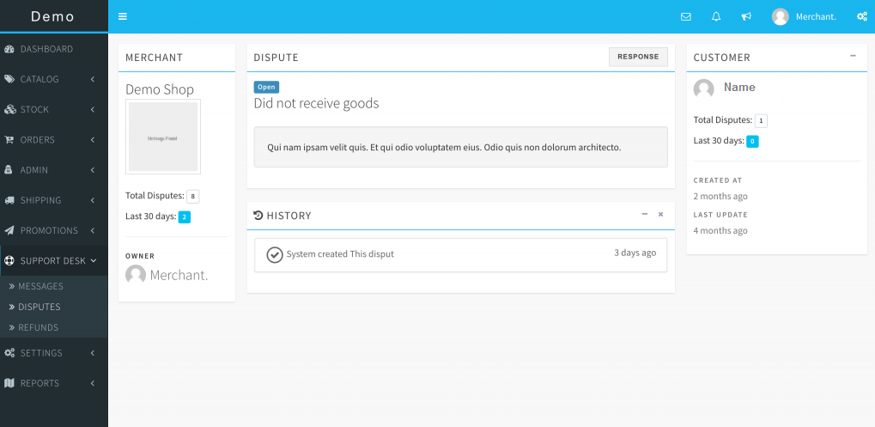

**Attention!** Only the support team of IndoMarche can change the status of the appealed disputes.

**Refunds**

When a dispute is opened by a customer, he/she can request for partial/ full refund for the order total too. You can initiate the refund too if you find it justified.

If you have complete permission to the system, you can also approve or decline the refund request from this section.

SUPPORT DESK >> REFUNDS

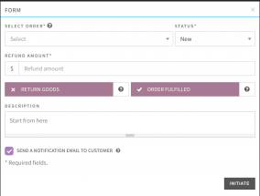

**Attention!** Initiating a refund will transfer the actual refund amount to the customer. Even after this, you will have to send the money from your account to the IndoMarche’s account.